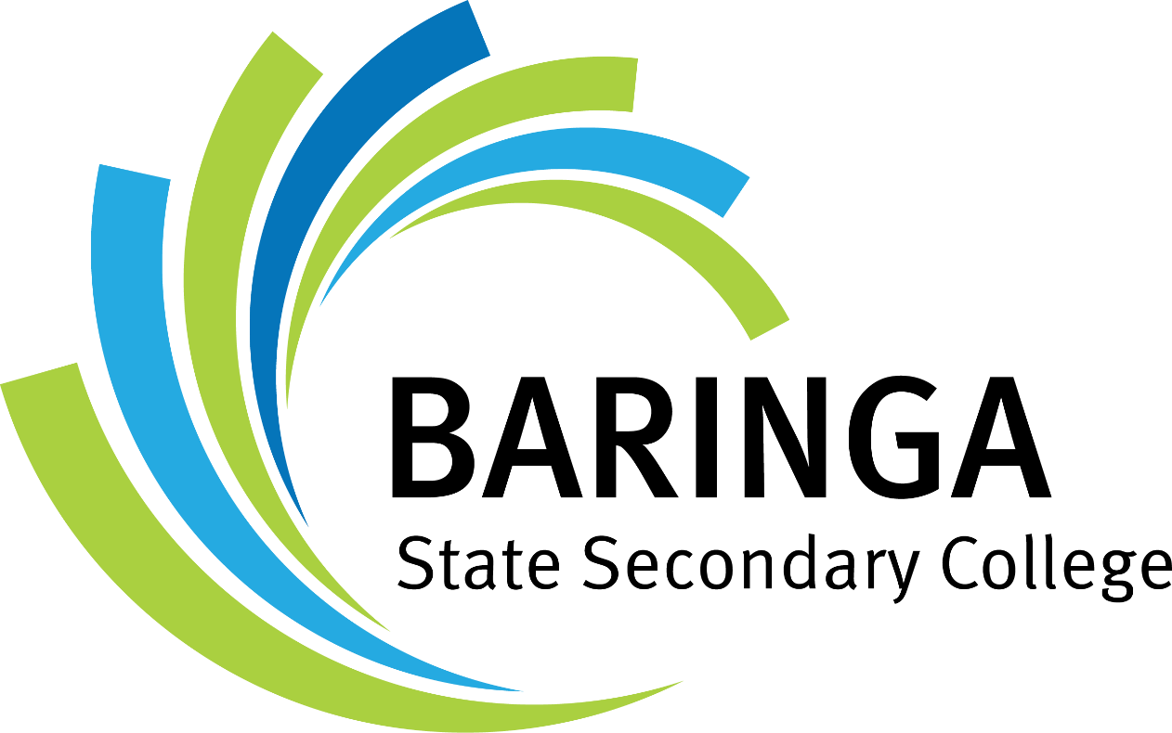

Summit Netball Program

Summit Netball Program Information Booklet
Contents
Summit Netball Program Information Booklet 1
Baringa SSC Summit Netball Program Vision Statement 1
Year 7 Overview 2
Year 9 Overview 3
Program Benefits 4
Curriculum 5
Strength and Conditioning 5
Top Tier Competitions 5
Netball Camps 5
Partnerships 5
Coaching Staff 5
Code of Conduct 6
Parent/Caregiver Expectations 7
Student Expectations 7
Breach of Expectations 8
Costs 8
Player Information 9

Baringa SSC Summit Netball Program Vision Statement
At the Baringa State Secondary College Summit Netball Program, we empower students to be confident, creative, and aspirational athletes and leaders—on and off the court. Through a culture of respect, integrity, and courage, our program fosters growth in athletic performance, personal values, and teamwork. We provide a supportive, high-performance environment guided by specialist staff where every player is valued, celebrated, and challenged to reach their summit. Through the Australian HPE Curriculum students will be exposed to all elements of being an athlete from targeted training, strength and condition, nutrition, recovery and personal ethics. We strive to inspire pride in every action, every game, and every future.

Program Overview
 | Term 1 | Term 2 | Term 3 | Term 4
Term Focus / Goal | - Program Orientation  - Goal Setting  - Nutrition and Wellbeing | - Positional focus areas  - Team Dynamics  - Nutrition and Wellbeing | - Tactical Awareness  - Skill refinement  - Nutrition and Wellbeing | - Year Review  - Goal Reflection  - Nutrition and Wellbeing
Training | 2 x Netball Lessons (in HPE)  - Baseline fitness  - Fundamental skills  - Teamwork & communication | 2x Netball Lessons (in HPE)  - Tactical awareness,  - game-play understanding | 2x Netball Lessons (in HPE for Yr 9)  1 x Training session (before/after school for Yr 7)  - Positional focus  - Leadership  - Game Analysis | 2x Netball Lessons (in HPE for Yr 9)  1 x Training session (before/after school for Yr 7)  - Skill consolidation  - Fitness re-testing  - Off season protocols
Strength and Conditioning (before/after school) | 1 x Strength and Conditioning  - Gym Orientation  - Injury prevention and Recovery Protocols  - Strength program development / Phase 1 | 1 x Strength and Conditioning  - Phase 2 of Gym Program  - Injury prevention and Recovery Protocols | 1 x Strength and Conditioning  - Phase 3 of Gym Program  - Injury prevention and Recovery Protocols | 1 x Strength and Conditioning  - Phase 4 of Gym Program  - Injury prevention and Recovery Protocols
Competitions | - Super 7s Competition  - Exhibition Match  - Athlete Workshop | - Super 7s Competition  - INFQ  - Gala Day Competition (Yr 7) | - Super 7s Competition  - INFQ Competition  - Gala Day Competition (Yr 9)  - High Performance Day | - Super 7s Competition  - Netball Day Camp

Program Benefits

Curriculum
Students within our program will have access to three netball focused HPE curriculum lessons run by specialised staff. Students are exposed to netball specific skills, targeted strength and conditioning sessions, nutrition, recovery and theory units which align with ACARA.

Strength and Conditioning
All year students will have access to at minimum 1 strength and conditioning session per week run in the school’s industry standard gym. Each year level has individualised training programs specific to Netball to ensure our student athletes understand how fundamental strength movement patterns improve on court performance and reduce risk of injury. These sessions are coached by staff with qualifications including degrees in Sport and Exercise Science, Certificate IV in Fitness and experience in elite sporting programs.

Top Tier Competitions
Our Netball Program of Excellence provides multiple opportunities for students to compete in competitions across the year.

High Performance Day and Workshops
Each year level will have the opportunity to engage with a netball high performance day. These provide the opportunity for our teams to work through challenging environments and activities to build communication, resilience and teamwork. Furthermore, student athletes will have workshops that focus on the importance of athlete training, nutrition and recovery.

Partnerships
Our program has links with a variety of community and industry leaders which students will interact with throughout the year. These include training clinics, nutrition seminars run by industry leading dietitians and recovery facilities.

Coaching Staff


Erin Stenhouse
Head Coach / Specialist Teacher

  Mitchell Wright  Sports Coordinator / Strength and Conditioning |   Makayla Krosch  A/Head of Department HPE

Code of Conduct
The Baringa State Secondary College Summit Netball is a Program of development that reflects our College’s commitment to empowering students to be confident, creative, and aspirational about their chosen future. Program participants are expected to model the school’s core values of Respect, Integrity, and Courage, both on and off the court.

Parent/Caregiver Expectations
By accepting a place in the Baringa SSC Summit Netball Program we:
- Understand and accept that the College reserves the right to withdraw a student’s place in the Program if false or incomplete information is provided.
- Accept the expectations and responsibilities outlined in this Code of Conduct.
- Acknowledge that student conduct, commitment, and performance in all areas of school life influence continued participation in the Program.
- Support the values, vision, and policies of Baringa SSC both at school and in the wider community.

Student Expectations
Summit Netball students are expected to:
- Commit to Growth
  - Show sustained effort and a growth mindset in all netball, academic, and personal development activities.
- Prioritise Summit Netball and School Engagement
  - Participate in all training, games, and events scheduled by the Program. School-based netball takes precedence over external sporting commitments unless agreed upon by Program staff and the Principal.
- Be a Role Model
  - Demonstrate leadership, sportsmanship, and school pride. Be a positive influence within the Program and wider school community.
- Represent School Values
  - Uphold the College’s core values of Respect, Integrity, and Courage through your actions, behaviour, and interactions on and off the court.
- Demonstrate Positive Conduct
  - Follow the Baringa SSC Student Code of Conduct. Maintain Good Standing by meeting behavioural, attendance, and academic expectations.
- Maintain Uniform and Equipment Standards
  - Always wear the correct school and Summit Netball uniforms and ensure all netball equipment is used responsibly and respectfully.
- Communicate Respectfully
  - Engage respectfully with coaches, staff, teammates, opponents, and officials. Address any concerns through appropriate channels.
- Meet Financial Obligations
  - Ensure full payment of Summit Netball and Student Resource Scheme fees by the due date or arrange an approved payment plan.

Breach of Expectations
Failure to meet the above expectations may result in:
- Minor Infringement: Warnings and coaching conversation
- Breach 1: Meeting with Parent/Carers
- Breach 2: Temporary suspension from Program activities
- Breach 3: Removal from the program (following consultation with student, caregivers, and leadership staff due breaches)
  - Baringa SSC is committed to restorative practice and will support students in regaining Good Standing when appropriate, then an opportunity for reinstatement in the program after a term of Good Standing.

Costs
To secure a position in the program, student athletes will be invoiced for their participation. This is in addition to the school compulsory Student Resource Scheme.
The yearly cost is $265 per student.
The deposit is $50 is due 21 days after acceptance letter is sent.
Full payment due Week 4 of Term 1 2027.
To organise a payment plan you are able to contact our front office.
The below chart details how the $265 course fee has been estimated.
EXPENSE Prediction 2027 | COST PER STUDENT
Netball dress hire | $19.00
Training shirt | $14.00
Project Lvlup Strength, Nutrition and Recovery Seminar | $20.00
High Performance Day | $40.00
Super 7s x 4 | $124.00
INFQ x 2 | $32.00
Umpires | $16.00
 | $265.00

Disclaimer – while all efforts have been made to include as many costing factors as possible, predictions can change. Due to these circumstances costs (for example transport) may arise throughout the year. Be assured you will be given plenty of warning if this happens.

Player Information
Student Details:
Name: |  | Date of birth:
Parent / Carer Details:
Name:
Relation: |  | Phone:
Email:
Address:

Student Information:
Current Club: |  |  | Grade: |  | Team:
Referee Name (e.g. coach): |  |  |  |  | Phone:
Preferred Playing Position: | 1. |  | 2. |  | 3.
Playing / Representative Experience
Why do you want to be considered for the program?

Academic and Behaviour Information:
Please list your 2 most current school report results
Report 1: | English | Math | HASS | Science | Behaviour | Effort
Report 2: | English | Math | HASS | Science | Behaviour | Effort
Attendance:

Supporting Documentation:
Please supply photocopies or electronic versions of the below:
- Two most recent school reports
- Copies of any excellence awards/acknowledgement relevant to netball
- Any other supporting evidence you like to be considered

